Reflected light (Bounce light)

📘 Definition
# Source: AI Source: Provided by: [Data Path: Persons Table -> ID Column: 1, Name_En Column: Motasem Essam] -> From: [ChatGPT] on [5/2/2026]
Reflected light (Bounce light) is light that hits a surface, bounces off it, and then lights up nearby objects.
It is not coming directly from the main light source, but from light that has already reflected off another surface.

💡 How bounce light works
# Source: AI Source: Provided by: [Data Path: Persons Table -> ID Column: 1, Name_En Column: Motasem Essam] -> From: [ChatGPT] on [5/2/2026]
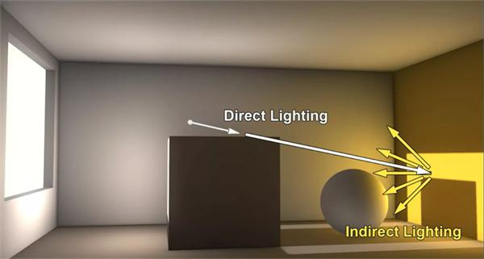
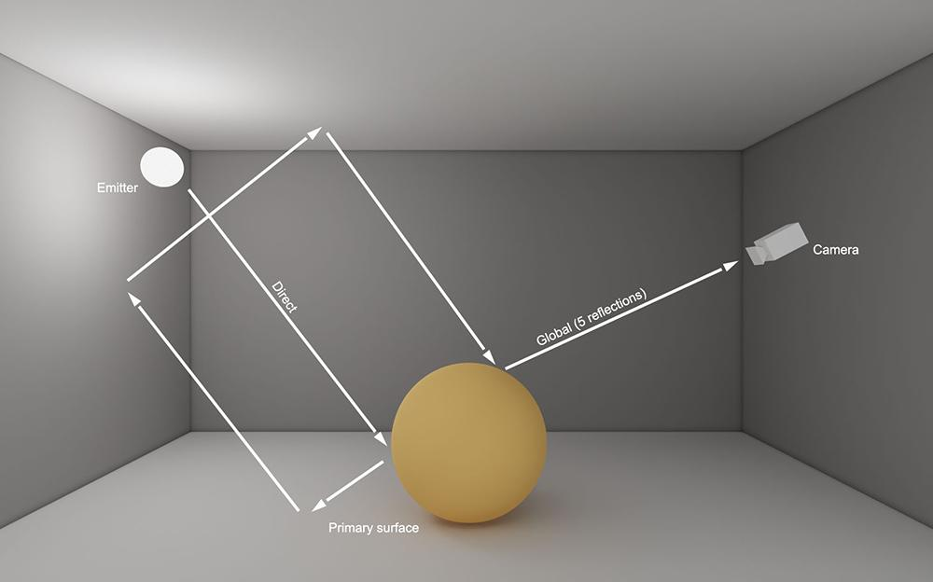
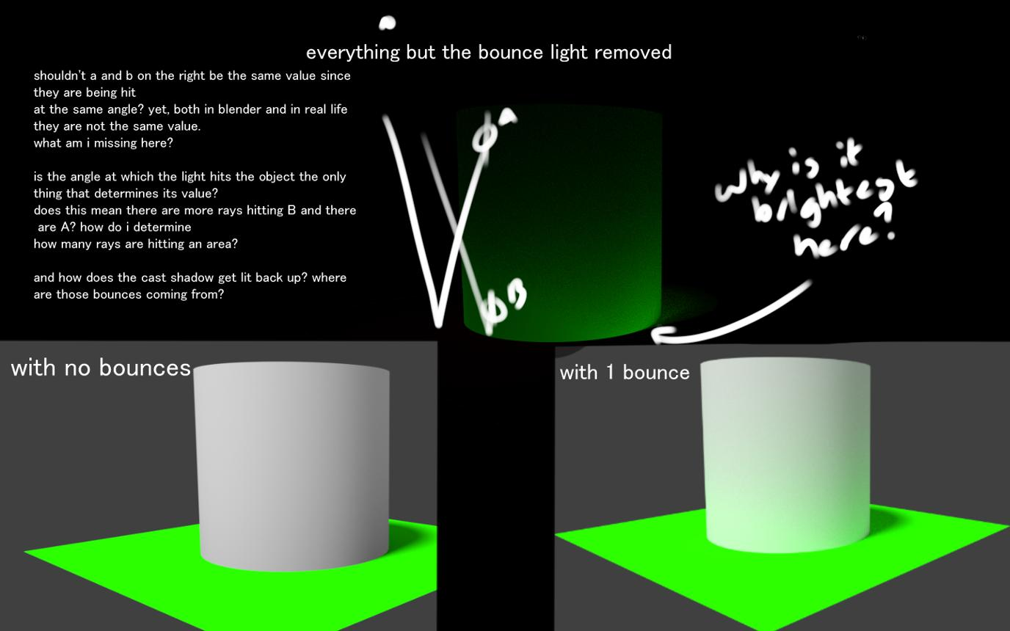
6
- A light source shines on a surface
- The surface reflects some of that light
- The reflected light bounces onto other objects
- This creates soft, natural illumination

🧠 Simple example
# Source: AI Source: Provided by: [Data Path: Persons Table -> ID Column: 1, Name_En Column: Motasem Essam] -> From: [ChatGPT] on [5/2/2026]
Think of:
- ☀️ Sunlight hitting a red wall
- The red wall reflects light onto a nearby white object
- The object gets a soft red glow even if it’s not directly lit

🎮 In computer graphics
# Source: AI Source: Provided by: [Data Path: Persons Table -> ID Column: 1, Name_En Column: Motasem Essam] -> From: [ChatGPT] on [5/2/2026]
Bounce light is used to:
- Make scenes look more realistic
- Soften harsh shadows
- Simulate indirect lighting (global illumination)
- Add natural color blending between objects

⚙️ Key features
# Source: AI Source: Provided by: [Data Path: Persons Table -> ID Column: 1, Name_En Column: Motasem Essam] -> From: [ChatGPT] on [5/2/2026]
- 🔄 Comes from reflected light, not direct light
- 🌫️ Very soft and subtle
- 🎨 Can carry color from nearby surfaces
- 🌍 Important for realistic 3D rendering

🚀 In short:
# Source: AI Source: Provided by: [Data Path: Persons Table -> ID Column: 1, Name_En Column: Motasem Essam] -> From: [ChatGPT] on [5/2/2026]
Bounce (Reflected) Light = light that bounces off one surface and indirectly lights other objects.

